Project electronics

electronics for security

PSB2000 Double Gate Controller from Project Electronics

Congratulations and thank you! You have purchased a PSB2000 gate controller, made to world class quality by a British company for the British environment. We hope and trust it will give you many years of trouble-free service. All markings on the board are in English.

The board is powered by UK mains electricity, and can provide power output to auxiliary devices requiring 24VDC, 12VDC or 12VAC, to a combined total of 2 Amperes. There are separate 240VAC, 12VDC and 24VDC fuses, identified on the board.

The PSB2000 accepts plug-in microcontrollers, dependant upon the function required. At present the two controllers are:

1. 108TN for single/double swing gates, full width single leaf pedestrian opening, no limit switches
2. SP5 for single swing or slide gate, variable single leaf pedestrian opening, limit switches

The functionality of your selected microcontroller code is briefly outlined on the following pages.

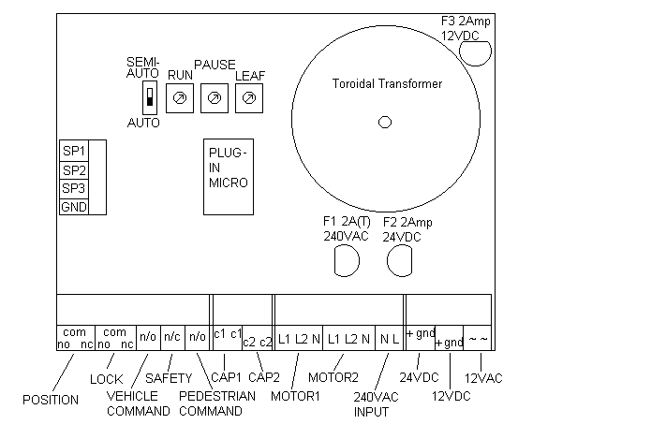
In the unlikely event of any failure, the board is covered by a full twelve months parts and labour warranty from date of purchase, or at any later date we will be pleased to repair it in our own workshops at modest cost.
Telephone 01243 814736, fax 01243 814453, or e-mail sales@ParsecUK.com, or see our website at www.ParsecUK.com
E&OE
108TN
Double gate code, full pedestrian opening, without limit switches

SP1 input when connected to GND disables PUSH-OPEN and PUSH-CLOSED (see paragraph 9.).
SP2 input controls LOCK operation (see paragraph 2).
SP3 input controls opening leaf delay (see paragraph 3.).

Two modes of operation, automatic and semi-automatic, controlled by a single slide switch setting on the board. The modes are:

108TN Mode 1: automatic

- POSITION relay, normally un-operated, operates when the gates are away from the closed position, and remains operated throughout the entire operation, until the gates are closed again. N/c and n/o contacts are available. All relays show a green LED when operated, and are field replaceable.
- LOCK relay operates for approximately three seconds when a command to open, either VEHICLE or PEDESTRIAN is received. The relay has VOLTLESS changeover contacts, and can therefore be used with either a magnetic lock (use n/c contacts) or electromechanical lock (use n/o contacts) by connecting a suitable voltage in series with the lock (see on-board power supplies). NOTE: when gates are held in the open position by permanent VEHICLE command, the LOCK relay remains operated. The intention of this is to disable a magnetic lock, so that if the gates are accidentally closed they do not lock closed. However, this would cause permanent operation of electromechanical locks, causing overheating and destruction. To run electromechanical locks with command hold-open, connect SP2 to GND. Note also that SP2 causes lock release stroke on opening.
- the gates receives a VEHICLE command into the normally open VEHICLE input, and then will open for the duration of the RUN timer, pause for a time set by the PAUSE timer, then close for the duration of the RUN timer plus two seconds. NOTE that gate 1 commences opening approximately two seconds before gate 2, to allow for rebated gates. If this feature is not required, connect SP3 to GND.
- motor runtime to open and close can be varied by a RUN rotary control on the board
- the duration of the pause in the open position can be varied by a PAUSE rotary control on the board
- an infra-red photocell beam (or other safety device) can be connected to the normally closed n/c SAFETY input on the board, such that if this beam is broken while the gates are closing, they will re-open, and wait until the beam is no longer obstructed. Note that the gates will only re-open for the duration they have been closing, plus two seconds approximately. **IMPORTANT: IF NO SAFETY DEVICES ARE FITTED, SAFETY INPUTS MUST BE BRIDGED i.e. CONNECTED TOGETHER WITH WIRE.
- as soon as the infra-red beam has been broken and cleared, the controller assumes the vehicle has passed through the gates, and cuts the PAUSE time, causing the gates to close immediately behind the vehicle, for security purposes.
- a separate PEDESTRIAN command input button or radio causes gate 1 only to open, pause for five seconds, then close. This is used to allow pedestrians to access without being ‘tail-gated’ in by vehicles. A VEHICLE command received during pedestrian operation will override, causing immediate vehicle mode, both gates opening.
- when using hydraulic rams, and when the gates are closed, the controller starts the ram motors once an hour for five seconds, to push the gates firmly closed. Also, if the gates are held OPEN by permanent VEHICLE or PEDESTRIAN command input, the controller will push the gates OPEN for five seconds every fifteen minutes. This ensures hydraulic pressure is maintained. If using electromechanical rams, and this feature is not required, connect SP1 to GND to disable the PUSH-OPEN, PUSH-CLOSED feature.

108TN Mode 2: semi-automatic

- the gates receive a command, open, and remain open until a second command is received, at which time they close
- all other features, including safety beams and pedestrian opening, are as for automatic mode

E&OE

SP5:
Single gate limit switch code with PED partial opening

This code has OPEN and CLOSE limit switch capabilities on gate 1 only (i.e. it is a single gate code). The OPEN limit switch connects between SP3 and GND inputs. The CLOSE limit switch connects between SP2 and GND inputs. SP1 input is unused. For limit switch operation please see paragraph 3.

Two modes of operation, automatic and semi-automatic, controlled by a single slide switch setting on the board. The modes are:

SP5 Mode 1: automatic

- POSITION relay, normally un-operated, operates when the gate is away from the closed position, and remains operated throughout the entire operation, until the gate is closed again. N/c and n/o contacts are available. All relays show a green LED when operated.
- LOCK relay operates for approximately three seconds when a command to open, either VEHICLE or PEDESTRIAN is received. The relay has VOLTLESS changeover contacts, and can therefore be used with either a magnetic lock (use n/c contacts) or electromechanical lock (use n/o contacts) by connecting a suitable voltage in series with the lock (see on-board power supplies).
- the gate receives a VEHICLE command into the normally open n/o VEHICLE input, and then will open for the duration of the RUN timer or until the OPEN limit switch is broken, whichever is sooner, pause for a time set by the PAUSE timer, then close for the duration of the RUN timer plus two seconds or until the CLOSE limit switch is broken , whichever is sooner. NOTE: the gate will not open if the OPEN LIMIT switch is already broken, or perhaps has become faulty or disconnected. The gate will not close if the CLOSE LIMIT switch is already broken at the start of the CLOSE cycle) **IMPORTANT: IF NO LIMIT SWITCHES ARE FITTED, LIMIT SWITCH INPUTS MUST BE BRIDGED i.e. CONNECTED TOGETHER WITH WIRE.
- motor runtime to open and close can be varied by a RUN rotary control on the board
- the duration of the pause in the open position can be varied by a PAUSE rotary control on the board
- an infra-red photocell beam (or other safety device) can be connected to the normally closed n/c SAFETY input on the board, such that if this beam is broken while the gates are closing, they will re-open, and wait until the beam is no longer obstructed. Note that the gates will only re-open for the duration they have been closing, plus two seconds approximately. **IMPORTANT: IF NO SAFETY DEVICES ARE FITTED, SAFETY INPUTS MUST BE BRIDGED i.e. CONNECTED TOGETHER WITH WIRE.
- as soon as the infra-red beam has been broken and cleared, the controller assumes the vehicle has passed through the gate, and cuts the pause time, causing the gate to close immediately behind the vehicle, for security
- a separate PEDESTRIAN command input button or radio causes the gate to PARTIALLY open, pause for five seconds, then close. This is used to allow pedestrians to access without being ‘tail-gated’ in by vehicles. A vehicle command received during pedestrian operation will override, causing immediate vehicle mode, full width opening. The amount by which the gate partially opens can be varied by adjusting the LEAF control (not required for leaf separation as there is only one gate in use with SP5 code).

SP5 Mode 2: semi-automatic

- the gates receive a command, open, and remain open until a second command is received, at which time they close
- all other features, including safety beams and pedestrian opening, are as for automatic mode

E&OE

